**Mono or Stereo using MAX98357A or PCM5102A**

***intro: what is Mono and Stereo audio output ?***

Mono and stereo are terms used to describe the number of audio channels used to play back audio.  
In mono audio output, a single audio channel is used to play back audio. This means that the audio signal is mixed into a single channel and played through a single speaker or headphone driver. Mono audio output is commonly used for voice-based content, such as phone calls or podcasts, where stereo audio output is not necessary.  
In stereo audio output, two audio channels are used to play back audio. This means that the audio signal is split into two channels, typically referred to as the left and right channels, and each channel is played through a separate speaker or headphone driver. Stereo audio output is commonly used for music and other audio content that contains separate left and right channels, such as sound effects in movies and video games.  
Stereo audio output can provide a more immersive listening experience than mono audio output, as it can create a sense of space and directionality in the audio. For example, if you're listening to a song in stereo, you might hear the guitar solo in the right channel and the vocals in the center, which can make it feel like the music is coming from multiple directions.

***How to play an audio file as a stereo output using MAX98357A?***

there are **2 methods** to do so, which we’ll discuss next:  
**1) by modifying the connections of the MAX98357A amplifier in the circuit using the SD pin.  
2) by configuring the I2S to send output only to the right\left channel through the code.**  
  
**NOTE:** The MAX98357A amplifier is a **mono** amplifier by default, so it’s not possible to directly play an audio file in stereo using just one amplifier. However, it is possible to create a stereo setup using two MAX98357A amplifiers, one for the left channel and one for the right channel.

**method 1 - using the SD pin:**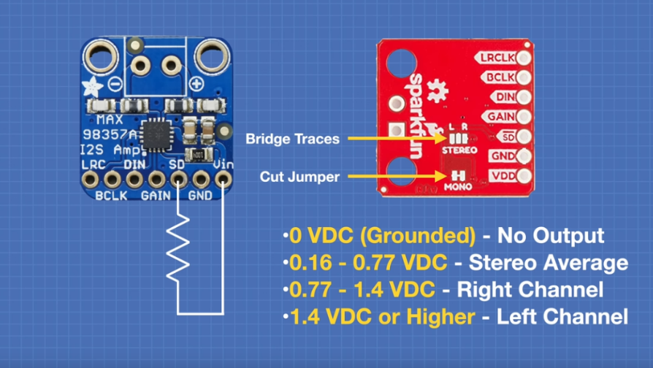in order to create a stereo output, we'll be using two max98357a amplifier modules and they need to be set to either only the left channel or only the right channel and you do that on most of these modules by using the SD pin. the SD is not the serial data pin, that is the DIN pin for the I2S. this is the pin whose voltage level determines the output mode of the amplifier.

* when this pin is grounded or set to **zero** volts the amplifier will have no output at all so you could use this as a form of a **mute** control if you wish.
* when the voltage level on SD lies between **0.16 - 0.77** volts dc then you will get a stereo average or mono signal out of the amplifier. this is the **default mode** because there is an internal pull down resistor on the board that maintains this voltage level.
* when the voltage level on SD lies between **0.77 – 1.4** volts the amplifier will output the **right channel**. you can use a pull-up resistor to the Vin in order to get the voltage higher.
* voltage level **higher than 1.4** volts it will output the **left channel**.

now if you happen to have a sparkfun implementation of this module it's a lot easier. there is a jumper on the bottom that is thereby default for mono and you can cut that jumper and then look above it at a couple of traces there is a center trace and two marked as l and r, you just need a blob of solder or some other way of shorting the traces so you can set this for either the left or right output accordingly.

**method 2 – redirecting the output through the code:**we’ll see how to redirect an audio file only to the right channel. in a similar manner, you can direct it only to the left channel, and then using 2 amplifiers, each one connected to a seperate speaker, you can play the audio file in stereo.  
using the I2S library provided with the ESP32. Here's an example code that shows how to configure the I2S output to play only the right channel:

#include "driver/i2s.h"  
  
// Set up I2S configuration  
i2s_config_t i2s_config = {  
 .mode = (i2s_mode_t)(I2S_MODE_MASTER | I2S_MODE_TX),  
 .sample_rate = 44100,  
 .bits_per_sample = I2S_BITS_PER_SAMPLE_16BIT,  
 .channel_format = I2S_CHANNEL_FMT_ONLY_RIGHT,  
 .communication_format = (i2s_comm_format_t)(I2S_COMM_FORMAT_I2S | I2S_COMM_FORMAT_I2S_MSB),  
 .dma_buf_count = 8,  
 .dma_buf_len = 64,  
 .intr_alloc_flags = ESP_INTR_FLAG_LEVEL1,  
 .tx_desc_auto_clear = true,  
 .use_apll = false,  
 .tx_mix = NULL  
};  
  
// Set up I2S pin configuration  
i2s_pin_config_t pin_config = {  
 .bck_io_num = 26,  
 .ws_io_num = 25,  
 .data_out_num = 33,  
 .data_in_num = I2S_PIN_NO_CHANGE  
};  
  
// Install and start the I2S driver  
i2s_driver_install(I2S_NUM_0, &i2s_config, 0, NULL);  
i2s_set_pin(I2S_NUM_0, &pin_config);  
i2s_start(I2S_NUM_0);

In this example, the I2S channel format is set to I2S_CHANNEL_FMT_ONLY_RIGHT, which means that only the right channel data will be sent to the amplifier that is connected to the right speaker.  
Once the I2S output is configured, you can play an audio file using any audio playback library or tool that supports I2S output. The audio data will be sent to the MAX98357A amplifiers through the I2S interface, with only the right channel data being sent to the amplifier that is connected to the right speaker.

***How to play an audio file as a stereo\mono output using PCM5102A?***

The PCM5102A is a **stereo** digital-to-analog converter (DAC) chip that has three output pins:  
 L, G, and R. (or the audio jack.)

The L and R pins are the left and right channel audio outputs, respectively. These pins output the analog audio signals for the left and right speakers. The signals are generated from the digital audio data that is input to the PCM5102A.

The G pin is the Ground reference pin. It is connected to the ground of the audio system to provide a common reference point for the audio signals.

When using the PCM5102A, you would typically connect the L and R pins to the left and right speakers, respectively, and connect the G pin to the ground of the audio system. The PCM5102A would then convert the digital audio data to analog audio signals and output them through the L and R pins for playback through the speakers.